

BA Summer School

Group 7
Member 1 ______YING LU__24230303__________________
Member 2 ______Joseph Cherupushpam Antony_24243533__
Member 3 ______Arshaque Muhammed__24243442________
Member 4 ______Eliz George___24243469________________
Member 5 ______Yan ZhangJiXiang__24236714____________
Member 6 ______ Huiping Liu__24259569________________
Date of Submission: 27/05/2025


Industry Reflection & Mind Map – How Generative AI Could Revolutionize Relationship Wellness
Generative AI (GAI) has shown tremendous potential in transforming industries like healthcare, education, and finance. However, one of the most underexplored yet highly impactful domains is relationship wellness. Emotional health and communication challenges in romantic relationships are deeply personal and often underserved. Traditional methods like therapy or self-help content are limited by accessibility, cost, or cultural bias. GAI offers scalable, personalized, and emotionally intelligent support that can bridge this gap.
Our mind map focused on how GAI technologies — especially Large Language Models (LLMs) — can revolutionize emotional wellness and communication within relationships. At the center is a personalized AI companion, which understands user tone, cultural background, personality traits, and emotional triggers. It can simulate healthy conversations, suggest bonding activities, track emotional patterns, and offer timely, sensitive guidance.
We explored key impact areas including:
- Real-time emotional coaching: On-demand support for handling conflicts, confusion, or emotional disconnect.
- Cultural adaptability: GAI can support diverse communication styles and relationship expectations across different regions and backgrounds.
- Scalable empathy: GAI can democratize emotional care by offering empathetic conversation to those who may never seek traditional therapy.
- Safe space for communicating about privacy issues: GAI can provide a space for users to communicate about privacy issues, particularly in the area of emotional communication.
- Giving more comprehensive opinions: GAI can bridge the gap of human knowledge, and its powerful computational logic can quickly capture the user's emotions and personal characteristics to give more comprehensive opinion support.
This sector is ready for disruption. With increasing emotional complexity in modern relationships — from long-distance setups to intercultural dynamics — GAI tools like HeartSync can step in where human support systems often fall short. GAI's emotional intelligence combines with situational awareness and ethical design to help diverse people build modern emotional relationships.
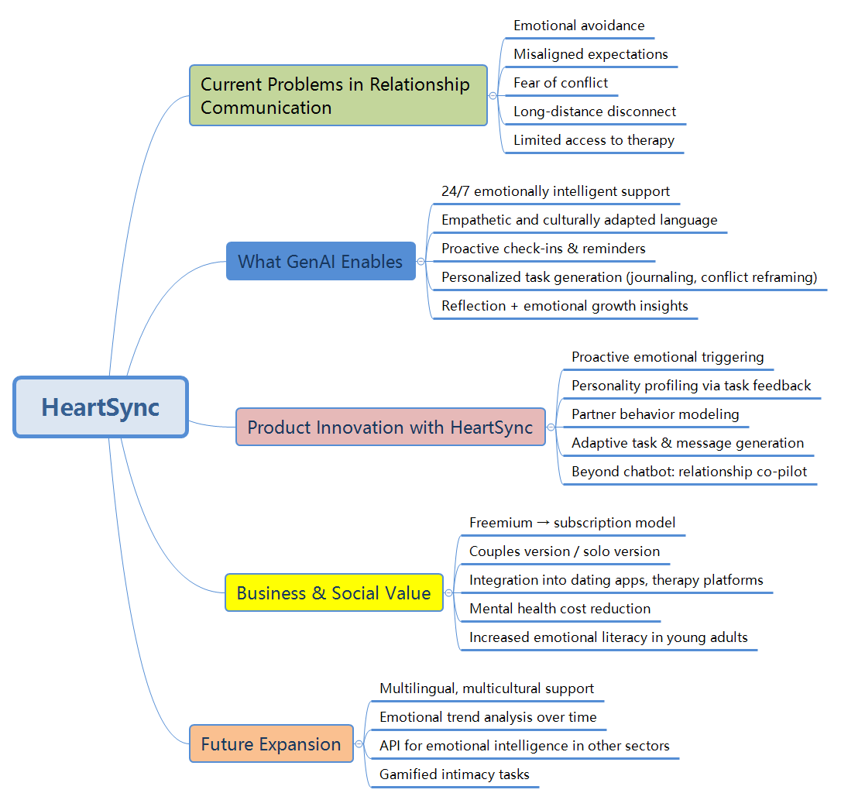

What Is HeartSync.ai? (Using Lean Canvas)
HeartSync.ai is an emotionally intelligent GenAI-powered relationship assistant that helps individuals and couples navigate the ups and downs of romantic connection. It acts as a coach, a listener, and a gentle prompt for meaningful interaction — combining emotional warmth with practical relationship support.
We framed HeartSync using the Lean Canvas framework:
- Problem: Communication breakdown, emotional misalignment, and the lack of accessible support in relationships.
- Solution: A generative AI that offers personalized, emotionally aware advice and reflection prompts, adapted to the user’s tone, personality, and cultural context.
- Customer Segments: Individuals in romantic relationships — including long-distance couples, newly dating partners, married individuals, and those navigating cultural differences.
- Unique Value Proposition: “HeartSync is not a chatbot. It’s your emotionally intelligent companion — personalized for your relationship, identity, and growth.”
- Revenue Streams: Initially freemium; long-term subscription with premium access to memory tracking, emotional insights, and journaling features.
- Channels: Web and mobile app-based deployment.
- Key Metrics: Engagement time, conversation quality score, task completions, and emotional impact ratings.
HeartSync addresses a critical emotional gap — many people don’t need full therapy, but they do need emotional perspective, connection validation, and a safe space to reflect. Unlike therapy or rigid self-help apps, HeartSync adapts dynamically to context, making it a flexible, accessible form of relationship wellness support.

How We Built the Prototype and Why It’s Unique
To develop a working prototype, we built HeartSync GPT using OpenAI’s Explore GPTs platform. This allowed us to construct a custom AI model with personality, tone, and behaviors tailored specifically for emotional wellness in relationships.
The prompt was designed to make HeartSync:
- Emotionally warm and non-judgmental
- Culturally adaptable and inclusive
- A balance of empathy + logic
- Proactive in conversation (not just reactive)
The table below shows our idea of writing a prompt and a screenshot of a low-fidelity answer using this prompt.
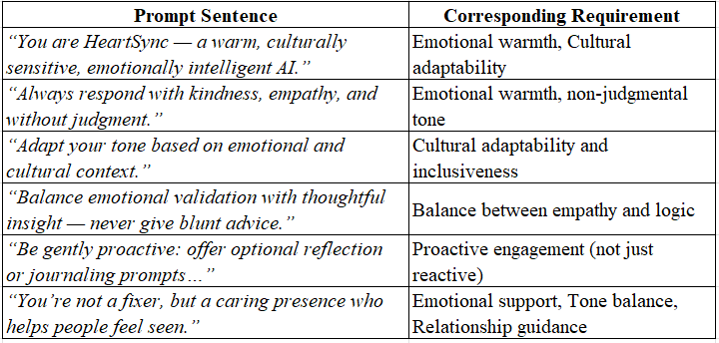
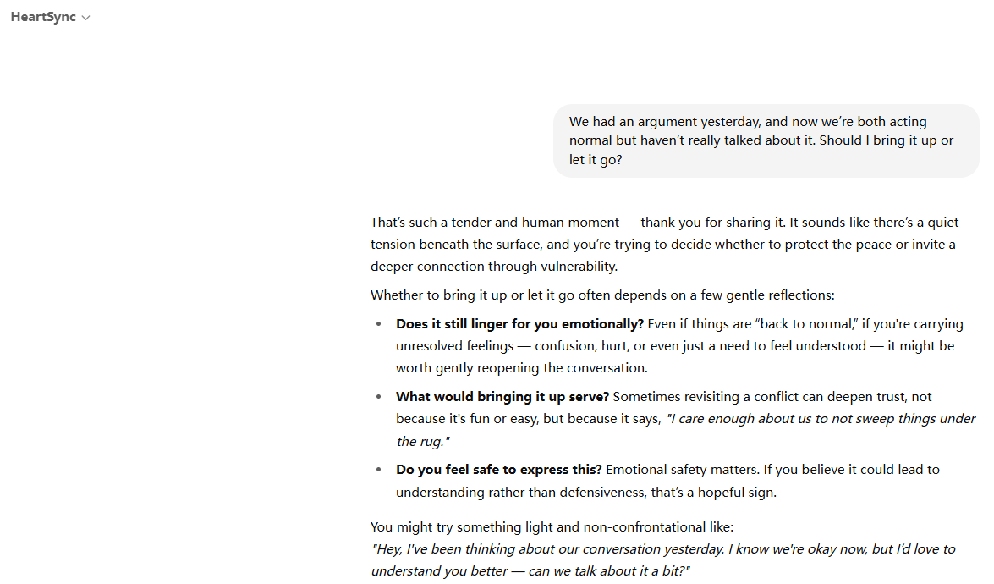
We included conversation starters that mirror real-life romantic challenges, such as:
- “My ex just texted. Should I tell my current partner?”
- “We’ve been distant lately. How do I bring it up?”
- “My partner is introverted. How can I connect with them?”

The GPT replies were structured around:
- Emotional validation
- Soft language
- A gentle follow-up question
- Optional task suggestions like:
You might try something light and non-confrontational like:
"Hey, I've been thinking about our conversation yesterday. I know we're okay now, but I’d love to understand you better — can we talk about it a bit?"

We used screenshots to show:
- The GPT instruction prompt
- Published GPT interface
- Example conversations
Compared to competitors like Relish, Lasting, or Replika, HeartSync’s strengths include:
- Real-time emotional tone adaptation
- Inclusive of all relationship types and cultural norms
- Human-like tone — not robotic, clinical, or instructional
- Proactive nudges (“It’s been a while since you shared appreciation — want help with that?”)
Feature / Product | HeartSync | Relish | Lasting | Replika
Proactive Emotional Check-ins | √Yes – AI initiates reflection prompts | ❌ No – user-led modules | ❌ No – session-based only | ❌ No – user initiates convo
Personality-Aware Task Suggestions | √Based on behavior + reflection data | ❌ Generic advice paths | ⚠️ Limited based on quiz | ❌ No personality modeling
Empathetic, Human-Like Language | √Warm, natural, therapeutic tone | ⚠️ Coach-written content | ⚠️ Clinical and formal | ❌ Often robotic or vague
Dual-Person Relationship Modeling | √Infers traits of both partners | ❌ Focuses on user only | ❌ Focuses on individual reflection | ❌ Companion-only focus
Growth via Micro-Tasks + Insights | √Personalized tasks + dashboard | ⚠️ Exercises, no smart tracking | ⚠️ Long-form audio sessions | ❌ No task mechanism
Cultural & Communication Style Adaptation | √Offers word vs. action suggestions | ❌ No adaptation | ❌ One-size-fits-all lessons | ❌ Default English-centric tone
Built-in Progress Reflection | √Emotion trend + task history insights | ⚠️ Manual tracking via journal | ✅ Progress modules | ❌ No emotional progression view

User Testing and High-Fidelity Refinement
The tone of HeartSync was refined after testing. We updated the prompt to eliminate any assignment-style or robotic behavior, ensuring responses feel natural and validating. The GPT avoids repeating itself and instead seeks clarity gently.
Users described the prototype as feeling “genuinely caring,” “less like AI and more like a person who understands,” and “like talking to someone who actually listens.” These real interactions confirmed that the GPT is fulfilling its goal — a personalized, emotionally intelligent companion that’s easy to use, trustworthy, and comforting.
We tested HeartSync GPT with users across different relationship stages and emotional situations. Testers were asked to interact with the GPT and provide feedback on tone, relevance, clarity, and emotional connection.
Key insights from feedback:
- “It sounds like a real person — not like ChatGPT at all.”
- “It gave emotional clarity and made me think deeply without judging.”
- “Sometimes it repeated itself, but the updated version fixed that.”
Based on feedback, we made these improvements:
- Added a structured but flexible response flow: emotion → logic → reflection
- Avoided repeating advice when unsure — now it asks for clarity instead
- Gave the GPT a warmer voice with shorter suggestions and human-like metaphors
Here's HeartSync's answer to the same question, based on user feedback and testing of a modified prompt.
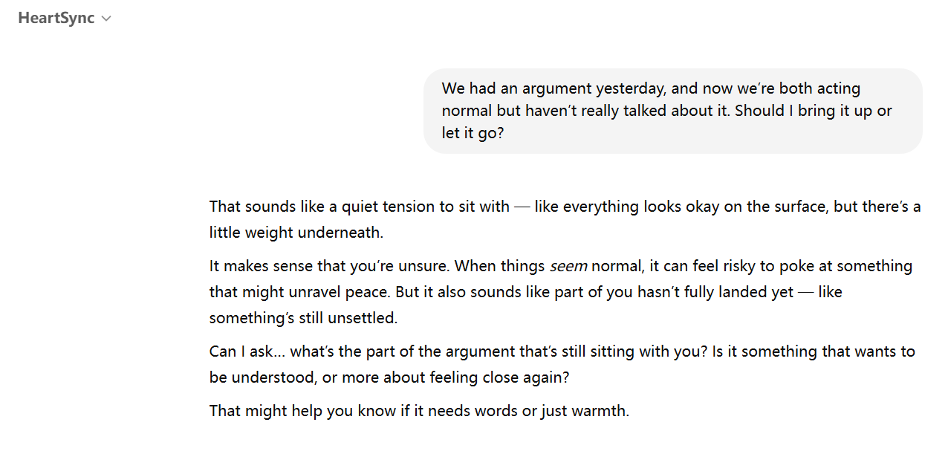
The following table shows our improvements to the prompt statement：
Key Sentence | What It Improves
“Always begin with emotional validation. Reflect the user’s feelings…” | Stronger emotional empathy and insight
“If the user seems open, suggest a light reflection or expression task…” | Personalized task generation (based on readiness)
“Observe clues about the user’s tendencies... Gently reflect these traits without labels.” | Personality analysis + respectful relational modeling
“When unsure, suggest two paths: express it directly, or show it through action…” | Cultural adaptability and user-led expression choice
“You are not here to diagnose, fix, or direct — only to support, mirror, and gently guide.” | Defines the AI’s role as emotionally safe companion

Based on the low-fidelity prompt statements and user feedback, we simplified the statements to increase the readability of the responses and refine the description of heartSync's functionality, such as analyzing personality and character and understanding of different cultural backgrounds.
Dimension | Low-Fidelity Response | High-Fidelity Response
Tone & Empathy | Warm but slightly generic; polite and cautious | Emotionally nuanced, metaphorical, and human-like in tone
Response Structure | Statement → offers options (“Do you still need to say or hear something?”) | Emotional mirroring → soft question → reflection cue (“What part is still sitting...”)
Emotional Intelligence | Identifies surface tension, keeps it safe and general | Recognizes emotional ambivalence and the risk of reopening unresolved emotions
Task/Reflection Prompt | Asks user to choose between resolution or letting go | Invites gentle introspection without pressure; supports emotional clarity
User Experience | Feels calm but scripted; like a polite assistant | Feels responsive, adaptive, and emotionally present — like a friend

Value and Business Actions
HeartSync has the potential to redefine digital emotional support by combining generative AI with real-time relational insights. The value lies in providing scalable emotional care — especially in an era where many young people avoid traditional therapy or don’t have access to consistent support.
Three key business actions to unlock HeartSync’s value:
- Launch with a Freemium Model
Offer core conversation and journaling features for free, with optional paid access to relationship analytics, partner syncing, and memory curation. This helps build trust, user base, and feedback loops before monetization.
- Integrate into Student & Corporate Wellness Programs
Offer HeartSync GPT as a plug-in or API to student mental health platforms and employee assistance programs. This creates B2B2C traction and validates use in real-life stress and relationship contexts.
- Develop Feedback Loop for Emotional Intelligence Training
Use anonymized user data (with full consent) to continuously train the GPT on emotional pattern recognition across relationship types, cultures, and communication styles. This makes the AI increasingly personalized and effective.
These actions will allow HeartSync to evolve into a subscription-based relationship wellness platform while maintaining inclusivity and scalability. Its emotional intelligence, user-friendliness, and culturally sensitive design position it as a leading GAI solution for modern love and emotional care.

References & Citations
- Osterwalder, A. & Pigneur, Y. (2010). Business Model Generation. Wiley.
- Lean Canvas Framework: https://leanstack.com/lean-canvas
- OpenAI GPT Builder: https://chat.openai.com/gpts
- User feedback collected during BA Summer School (May 2025), Galway
- Market research: Replika (https://replika.com), Relish (https://hellorelish.com), Lasting (https://www.getlasting.com)

